Smart Talent Employee Engagement Worksheet

Understanding my company’s current level of Employee Engagement
“Employee engagement is a property of the relationship between an organization and its employees.” Discretionary effort is the level of effort people could give if they wanted to, but above and beyond the minimum required.
- Do your employees routinely give discretionary effort?
Strongly Disagree | Disagree | Somewhat | Agree | Strongly Agree
1 | 2 | 3 | 4 | 5

Gives examples of some of the discretionary efforts you have observed.

- In what areas of your company do low levels of engagement affect most. (Select all that apply)

- Customer service
- Productivity
- Product quality
- Company brand
- Financial performance
- Other __________________

- How many times in a week do you do one of these things?:
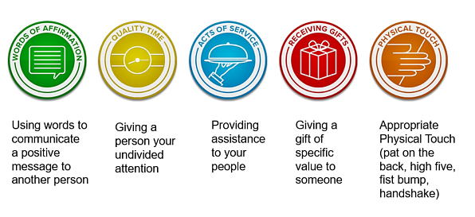

- Do you currently use a regular Employee Survey to collect employee engagement data? If not, design your own by selecting the from the list of questions below and using the scale provided

- I know what is expected of me at work.
- Once my most recent training was completed, I was fully prepared to do my work.
- I have the materials and equipment I need to do my work correctly.
- At work, I have the opportunity to do what I do best every day.
- In the last seven days, I have received recognition or praise for doing good work.
- There is someone at work who encourages my development.
- Within the last six months, someone at work has talked to me about my progress.
- Within the last year, I have had opportunities and work to learn and grow.
- In the last month, how many hours have I been given at work for training and development (provide any additional comments you would like to share).
- How strongly do you recommend our company to others.

Strongly Disagree | Disagree | Somewhat | Agree | Strongly Agree
1 | 2 | 3 | 4 | 5

You can deploy the survey using the tool Survey Monkey: https://www.surveymonkey.com/ or OMEP can assist you to set your survey up.

Creating an Employee Engagement Strategy
- Which of the following areas of engagements are you and your company willing to focus on? (Select all that apply)

- Recognizing employees for a job well done
- Provide employees with meaningful work
- Have senior leaders prioritize engagement
- Work to lower our turnover rates
- Provide career growth opportunities
- Instill good leadership behaviors in managers
- Create and implement a reward and recognition system
- Provide training and coaching opportunities
- Provide the right tools - making sure employees have all the tools they need to succeed in their roles.
- Give individual attention - figure out which approach will work best in your diverse workplace.
- Listen to employees to pinpoint and quickly address problems to make people feel valued.
- Get social to help employees care more about their workplace is to foster closer connections to colleagues.
- Provide opportunities for service for others – community or other service projects can help workers cultivate closer relationships.
- Other __________________

Creating an Employee Engagement Action Plan
- Action plans help people know what needs to be done to complete a task, project, initiative or strategy. An action plan generally includes steps, milestones, and measures of progress, as well as responsibilities, specific assignments, and a time line.

Leadership focus… | Supervisors focus… | Employees focus…
- Earns employees trust and confidence | - Coach employees to improve performance  - Treat employees with respect  - Act in ways consistent with their words | - Understand the organization’s business goals  - Understand the steps they need to reach those goals  - Understand how their job contributes to achieving those goals

Action Plan

What 1 or 2 things can your do RIGHT NOW?

What 3 – 5 things can you implement in the NEXT 6 months?

Repsonsible Person
Who will complete the action?

Deadline
When will the task be completed?

Resources Needed
What do you need to complete this step?

Potential Obstacles
What will you do to overcome them?

Expected Outcomes
What are the expected results?

